**The 24/7 Gardener Interm Report.**

Student Name: TJ Fitzpatrick

Student Number: 20027865

Date: 13-02-2020

Course: HDip In Computer Science.

Waterford Institute of Technology.

# **Introduction.**

This project is an application of green technologies for sustainable living. An indoor garden will be created, where plants (Snake Plant, Peace Lilly and Spider) will help clean and recycle the air. The technological solution will measure the oxygen and carbon dioxide levels in the air, and display this using an android application. Building on this idea, other fruit and vegetables will be grown with the aid of robots to assist with irrigation by using thresholds for dryness and wetness.

This project is broken into 2 parts, the hardware, and the software.

The hardware includes different sensors to measure different quantities in the garden then a native Android app will be built to monitor and display these values of the garden.

An analysis of green technologies based on IOT solutions will be carried to identify potential

solutions and features for my project. These include:

1. The Raspberry Pi Powered Garden.

2. The Automated Garden System Built Of Raspberry PI For Outdoors or Indoors. (mudpi, 2020)

3. Smart Home Gardening System Using Raspberry Pi. (P, 2017)

# **Hardware Requirements.**

## **Main Controller.**

Upon researching and evaluating 4 different single board computer technologies I was decided to use the Raspberry Pi as the main controller.

The reason being was when we compared the Pi to other boards there was a lot more information and sensors available online.

### **Raspberry Pi Vs ODROID XU4.**

I chose the Raspberry Pi in this case, for one reason is for the greater RAM will help run applications faster but the main reason is the Pi has a huge global community which is unmatched.

This means there’s ample information and supports for new users as well as continued development and maintenance of software.

Although the ODROID community is growing fast.

### **Raspberry Pi Vs ASUS Tinker Board.**

### Overall, both the Raspberry Pi 4 and the Asus Tinker Board have strong online communities, and great support, for open-source projects available to try out.

### However, the Tinker Board is from 2017 and definitely shows its age in comparison to the connectivity options of the Pi 4.

### Also the current price of the Tinker board far outweighs my budget compared to the Raspberry Pi which is more affordable in my case.

### **Raspberry Pi Vs Arduino.**

The Raspberry Pi can do everything that an Arduino can do, but it does need a little help in the form of HATs and add on boards, because certain features like analog-to-digital conversion aren’t built in there are a lot more libraries available online and a lot more tools available for the PI compared to the Arduino.

The Arduino is a truly versatile board but the Raspberry Pi is a full computer.

If you need wireless communication, raw processing power and access to the GPIO then the Raspberry Pi gives you all of that in a small package.

|  |  |  |  |  |  |
| --- | --- | --- | --- | --- | --- |
| **Controller** | **Cost** | **RAM** | **GPIO** | **Bluetooth** | **WIFI** |
| Raspberry Pi 4B | $35.00 | 8GB | 40 pin | V5.0 | Wi-Fi 802.11b/g/n |
| ODROID XU4 | $95.00 | 2GB | N/A | N/A | Wi-Fi 802.11b/g/n |
| ASUS Tinker Board | $105.00 | 2GB | 28 pin | BLE | Wi-Fi 802.11b/g/n |
| Arduino | $24.05 | 2K SRAM 1K EEPROM | 20 pin | Add on Board | Add on board |

## **Sensors.**

The sensors I found online include soil moisture, light, air qualit , temperature and humidity.

### **Temperature and Humidity.**

When researching temperature and humidity sensors, I came across two different family related sensors the DHT11 ad DHT22, I decided to evaluate both.

The benefits of these type of sensors include great long-term stability and low consumption of power.

In addition, you can get relatively high accuracy in measurement at an affordable rate.

Both use the same family of internal chips but only one is more accurate than the other.

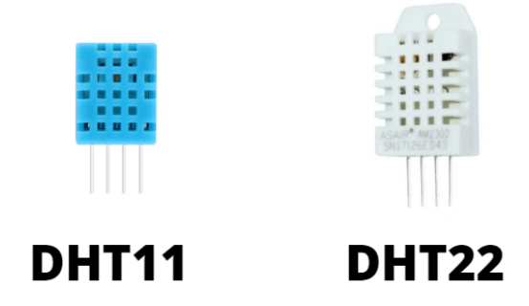

|  |  |  |  |  |  |
| --- | --- | --- | --- | --- | --- |
|  | **Temperature Range** | **Temperature Accuracy** | **Humidity Range** | **Humidity Accuracy** | **Cost** |
| DHT11 | -20 to 60℃ | ±2% | 5 to 95% RH | ±5% | $5.90 |
| DHT22 | -40 to 80℃ | ±0.5% | 0 to 100%RH | ±2% | $9.90 |

The DHT22 outshines the DHT11 in every aspect from temperature range, temperature accuracy, humidity range to humidity accuracy.

The only downside of the DHT22 is, of course, the slightly higher price but you are paying for the better specs.

### **Soil Moisture.**

I evaluated two different soil moisture sensors, but the sensor I’m going to go with is is the YL-69 Sensor.

The reason being is that both send back an analogue reading for the soil moisture, but because I decided to use the Raspberry Pi it cannot read an analogue measurement.

So the YL-69 has an extra built on board that will allow me to set the sensitivity value once this value has been passed the board will send a logic one to the Raspberry Pi.

If I was going to use the Aideepen I would have to use an Arduino or some other Microcontroller that reads analogue signals and then send this signal to the PI over some type of bus or even wirelessly.

|  |  |
| --- | --- |
| **Aideepen** | **YL-69 Sensor** |
|  |  |

### **Light Sensor.**

There are 2 types of light sensor that I have been evaluating and within my price range. They are called the BH1750, lm393.

I have decided to use the BH1750.

The BH1750 is one of the most advanced sensors that can be used in robotics to measure the light.

The sensor has digital signal output and is compatible with the Raspberry PI I2C bus interface.

The output is the value of light in Lux (Lx), and is the easiest way to measure the light without making any calculation.

The LM393 is a special light sensor that can sense the direction of the light and the light intensity.

The sensor can be directly connected to the digital or the analogue pins of the microcontroller or the digital pins of the Raspberry Pi.

Its features include a digital potentiometer to adjust the sensitivity, but its not more precise than the BH1750.

|  |  |
| --- | --- |
| **Lm393.** | **BH1750** |
|  |  |

### **Air quality Sensor.**

At this moment I have only found one senor for Air quality and that is MQ-35.

I just waiting for it to arrive so I can only talk about the specs I read about.

This sensor is an Air quality sensor is for detecting a wide range of gases, including NH3, NOx, alcohol, benzene, smoke and CO2. Ideal for use in office or factory, simple drive and monitoring circuit.

**Water Pump.**

The following is a 5V water pump that turns on when the Pi sets a logic high on one of its GPIO outputs.

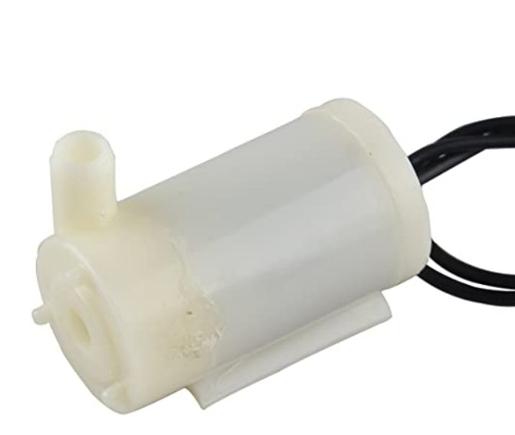

I was investigating dual water pumps but the prices on then were beyond my budget.

Just investigating this further there will probably be multiple pumps, so I might have to get a water level sensor, but I will evaluate this further into the project.

# **Software Requirements.**

## **Database (Firebase vs Mongo)**

|  |  |  |
| --- | --- | --- |
| **Name** | **Firebase Realtime Database** | **MongoDB** |
| Description | Cloud-hosted Realtime document store. iOS, Android, and JavaScript clients share one Realtime Database instance and automatically receive updates with the newest data. | One of the most popular document stores available both as a fully managed cloud service and for deployment on self-managed infrastructure |
| Primary database model | Document store | Document store |
| SQL | no | Read-only SQL queries via the MongoDB Connector for BI |
| APIs and other access methods | Android  iOS  JavaScript API  RESTful HTTP API | proprietary protocol using JSON |

I have chosen to the firebase Realtime Database only because there are API’s available for the Android operating system, and it will make the project development life cycle a lot more efficient, in the future there could be a possibility to change to a Mongo DB, but for now it will be a Firebase Realtime Database.

## **Android Studio (Kotlin vs Java).**

The android application will be written in Kotlin, the only reason behind this is that I believe Kotlin will eventually replace Java, I want to develop more applications after this course so it will be a really nice skill to develop.

The following images is what I would like to see within the application, or at least its how I can only see the application running, but in saying that if I completely follow through on my vision of the application then I will be too narrow visioned, so I really have to keep an open mind.

Talking to my supervisor there are other ideas worth investigating but I will need more research to implement these ideas.

## **Network Architecture Diagram**

The following image is of a Network Architecture Diagram on how I think right now the system could work.

